“An Emerging Threat: The Impact of Hypersonic Weapons on National Security, Crisis Instability, and Deterrence Strategy”
By Rylie White

INTRODUCTION
In the 20th century, the nuclear bomb was viewed by the public as one of the single largest threats to human existence; even in the past few years, media and expert discussions involving national security greatly focus on the threat of global nuclear conflict. However, technological advancements in hypersonic flight have given rise to an entirely new class of weapons that will exacerbate this threat to international peace and security. In 2017, Air Force General John Hyten, head of U.S. Strategic Command reported that China and Russia are “aggressively pursuing” hypersonic weapons and, when discussing United States missile defense, stated, “We don't have any defense that could deny the employment of such a weapon against us.” ¹
Hypersonic weapons are characterized by their capacity to travel at and maintain speeds higher than Mach 5, or 5 times the speed of sound. Two types of hypersonic weapons are currently in development: Hypersonic Cruise Missiles (HCMs), which operate similar to existing subsonic cruise missiles and are sustained by aerodynamic lift, and Hypersonic Glide Vehicles (HCVs) which are launched on a ballistic missile, but are released to quickly re-enter the atmosphere in order to “glide” at a flatter trajectory to their target. Both types of vehicles can be maneuvered during flight, and their targets and trajectory may be altered.²
The high speed, maneuverability, and relatively low altitudes at which hypersonic weapons fly make them a serious threat to United States national security and to the security of the United States’ allies and interests abroad. Hypersonic weapons have the potential to nullify existing missile defense systems, to destabilize military balances abroad, and to heavily alter deterrence strategies. Although the deployment of a hypersonic weapon by any nation is still years away, the United States must prepare to deal with the consequences. Thus, the United States Government must act to prevent the spread of hypersonic weapons technology and look to technological capabilities for defending against an offensive strike.

HYPERSONIC WEAPONS RESEARCH AND TESTING: CHINA, RUSSIA, AND THE UNITED STATES
In the past decade, the United States’ adversaries have demonstrated substantial interest in obtaining hypersonic weapons. Beijing first tested its WU-14 hypersonic glide vehicle in January 2014 and, in November 2017, carried out two successful tests of its DF-17 HGV, capable of Mach 10 speed, with a range of 1,000-1,500km.³ President Vladimir Putin has also boasted Russia’s hypersonic weapons program with successful tests in 2018 of the KH 47M2 Kinzhal missile, also capable of reaching Mach 10 speed and having a 2000 km range.⁴
In contrast to the United States’ intentions for hypersonic systems, both the Russians and the Chinese are pursuing vehicles which could deliver a nuclear payload. The United States, on the other hand, has added hypersonic weapons to its “Conventional Prompt Global Strike” strategy which, according to a Congressional Research Service report, would “supplement U.S. conventional capabilities” and “allow the United States to strike anywhere on Earth in as little as an hour.”⁵
IMPLICATIONS OF HYPERSONIC WEAPONS TECHNOLOGY
I .Hypersonic Weapons Will Nullify Existing Missile Defense Systems
The United States is not equipped to deal with the threat posed by hypersonic weapons due to their high speeds, maneuverability, and the low altitudes at which they fly. Ground based missile detection can be effective against traditional ballistic weapons because they exit and reenter the atmosphere at a high trajectory and the missile’s location and target can be predicted using physics.⁶ Conversely, hypersonic weapons travel at relatively low altitudes and remain closer to the atmosphere. Due to the curvature of the earth, this low, flat trajectory creates a large barrier for early detection (See RAND figure 2.2).⁷

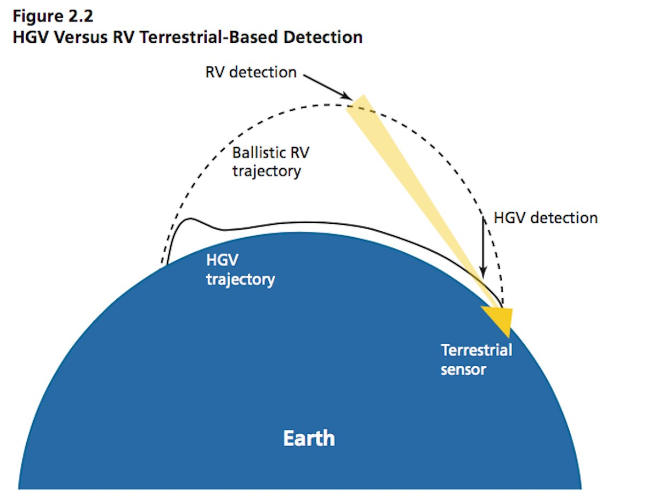

The issue of detection and interception of hypersonic weapons is further complicated by their maneuverability; a hypersonic vehicle’s target can be changed mid-flight which, compounded by hypersonic speeds, makes early detection difficult to impossible. (See RAND figure 1.3)⁸

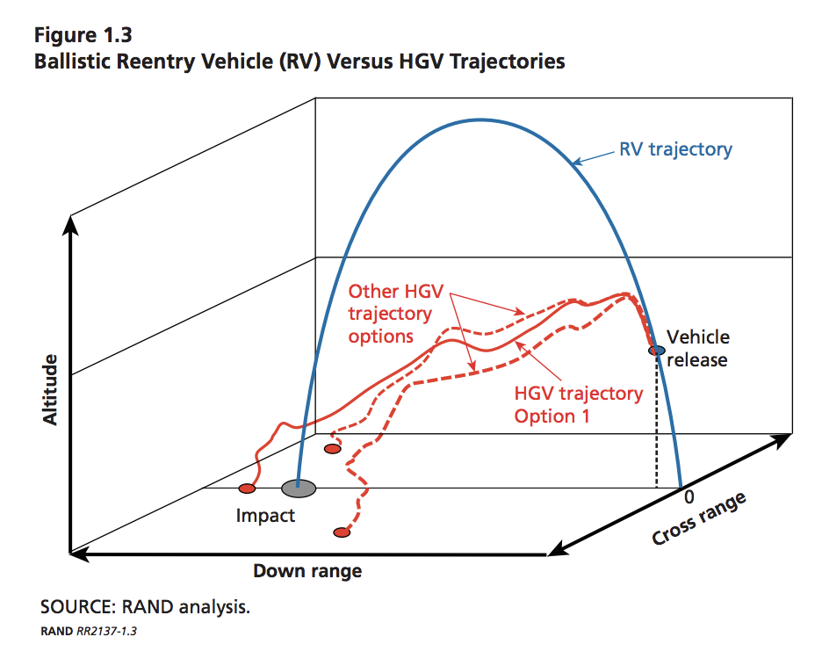

II. Hypersonic Weapons Will Contribute to Crisis Instability on Global and Regional Scales
The extreme speeds of hypersonic weapons coupled with their ability to evade missile detection will ultimately contribute to crisis instability in the event of large scale military conflicts as well as conflicts in smaller theatres. Crisis instability can be defined as “the condition that exists when either leader feels pressure because of emotion, uncertainty, miscalculation, misperception, or the posture of forces to strike first to avoid the worse consequence of incurring a first strike.”⁹
The time actors have to react to an attack will be severely reduced and their ability to detect a delivery system’s intended target will be hindered. As a result, nations may be forced to take on “trigger happy postures” in the event of an escalating conflict. Nations like China possessing hypersonic weapons could be problematic for United States interest in the Pacific and could cause problems for regional stability. Additionally, the Russian government has expressed concerns with these problems and worries that use of such long range missiles could increase the likelihood of misperceptions. Russia claims it would not be able to discern whether missiles flying in Russia’s direction were directed at other targets.¹⁰ This factor may pressure Russia to launch a preemptive strike if they cannot determine if they are being targeted. The inability to discern enemy targets as well as the inability to detect and react quickly to a hypersonic attack could lead to the dismantling of traditional deterrence strategies.
FINDINGS AND POLICY RECOMMENDATIONS
I. The U.S. Government Should Prioritize Development and Continued Support of Space-Based Missile Detection
Because hypersonic weapons could nullify terrestrial missile defense systems, the United States should continue to support comprehensive programs that employ space-based missile sensors alongside existing terrestrial defense systems. Specifically, this support should be directed with hypersonic weapons in mind. Utilizing outer space for missile detection provides a large advantage for combating threats in strategic regions around the world; development of such technology can be carried out under leadership of the Missile Defense Agency (MDA), alongside the United States Air Force (USAF) and other defense agencies.
In 2018, Air Force Lt. General Samuel Greaves, director of the MDA has specifically requested $37 million for continued operation of its Space Tracking and Surveillance System (STSS) for fiscal year 2019, which he reports has exceeded its life expectancy but has proven to be a worthwhile investment. ¹¹ However, combatting the hypersonic weapons threat will require more than just improving STSS. The MDA has begun to envision space-based sensor architecture which utilizes infrared sensing. A layer of satellite sensors could better detect missiles in boost phase (for example, before a HGV is released from its ICBM vehicle), could allow for detection of dimmer targets, and could more easily track missiles during their mid-course phase.¹² Detection and tracking of a missile from space helps surpass the physical challenges described earlier in this paper and could ultimately allow the United States to better utilize its interception systems on the ground.

II. The U.S. Government Should Work With China and Russia to Regulate Export and Proliferation of Hypersonic technology.
China, Russia, and the United States are the leading powers in hypersonic weapons technology research, but many other nation states are pursuing similar capabilities--both for military and civilian purposes.¹³ Because of the destabilizing threat of hypersonic weapons, it is critical for the United States, China and Russia to contain the weapons technology.
Although a nonproliferation treaty will not completely stop the inevitable spread of hypersonic technologies, it has the power to lengthen the timeline of proliferation. As suggested by a RAND 2017 report, export control of complete hypersonic missiles and their major subsystems can be an effective means of containing the technology, due to the difficulty of indigenous development. Hypersonic weapons programs are extremely expensive and building a viable weapon has several aerodynamic challenges. ¹⁴

CONCLUSION
Because hypersonic weapons development has the potential to nullify existing missile defense systems and contribute to crisis instability on large and local scales, the United States Government should take a two-pronged approach to prepare for this technology. Supporting development of satellite-based detection systems can allow for better “detect on launch” capabilities and can be used to conjunction with ground-based interception systems. Additionally, export controls on hypersonic systems, though not a permanent solution, can lengthen the timeline of global proliferation as the United States improves its missile defense capabilities.
Works Cited
- Hyten, John. STATEMENT OF JOHN E. HYTEN COMMANDER UNITED STATES STRATEGIC COMMAND BEFORE THE HOUSE ARMED SERVICES STRATEGIC FORCES SUBCOMMITTEE 7 MARCH 2018. www.stratcom.mil/Portals/8/Documents/2018%20USSTRATCOM%20HASC-SF%20Posture%20Statement.pdf?ver=2018-03-07-125520-187.
- Acton, James M. “Hypersonic Weapons Explainer.” Carnegie Endowment for International Peace, carnegieendowment.org/2018/04/02/hypersonic-weapons-explainer-pub-75957.
- “China Fires up New Hypersonic Missile Challenge to US Defences.” South China Morning Post, South China Morning Post, 2 Jan. 2018, www.scmp.com/news/china/diplomacy-defence/article/2126420/china-fires-advanced-hypersonic-missile-challenge-us.
- Missile Defense Project, "Kinzhal," Missile Threat, Center for Strategic and International Studies, published March 27, 2018, last modified July 18, 2018, https://missilethreat.csis.org/missile/kinzhal/.
- Woolf, Amy F. “Conventional Prompt Global Strike and Long-Range Ballistic Missiles: Background and Issues.” Federation of American Scientists, Congressional Research Service, fas.org/sgp/crs/nuke/R41464.pdf.
- Speier, et al. “U.S.-Russia-China Cooperation Could Hinder the Proliferation of Hypersonic Missiles.” RAND Corporation, 27 Sept. 2017, www.rand.org/pubs/research_reports/RR2137.html.
- Ibid
- Ibid
- Linhard, Robert E. “Crisis Stability in a Multi-Polar World.” SpringerLink, Springer, Dordrecht, 1 Jan. 1995, link.springer.com/chapter/10.1007/978-94-015-8396-1_6.
- Weitz, Richard. “Arms Racing in Strategic Technologies: Asia's New Frontier - by Richard Weitz.” Policy Centers - Center for Global Prosperity - Hudson Institute, www.hudson.org/research/11307-arms-racing-in-strategic-technologies-asia-s-new-frontier.
- Greaves, Samuel A. “Lieutenant General Samuel A. Greaves, USAF Director, Missile Defense Agency Before the Senate Armed Services Committee Strategic Forces Subcommittee.” Missile Defense Agency, 2018.
- Judson, Jen. “MDA Director Provides Rough Sketch of Possible Space-Based Missile Defense Sensor Layer.” Defense News, Defense News, 9 Aug. 2018, www.defensenews.com/digital-show-dailies/smd/2018/08/08/mda-director-provides-rough-sketch-of-possible-space-based-missile-defense-sensor-layer/.
- Speier, 6
- Ibid

